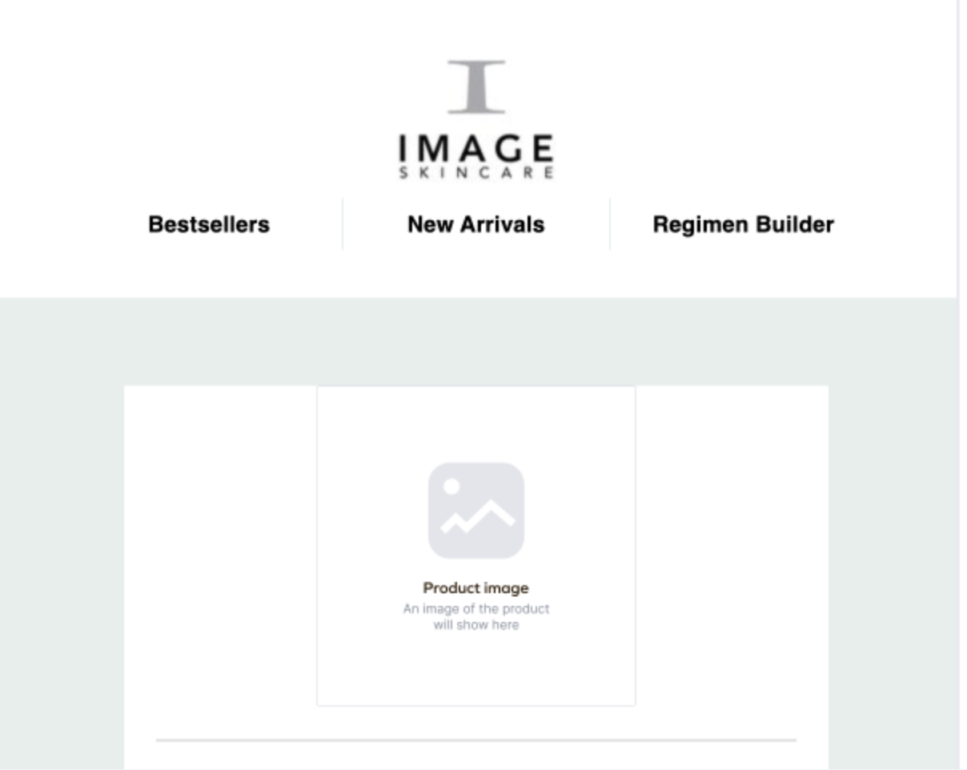

"Hi, [Insert Customer First Name], Thank you for submitting a product review for Image Skincare's [Insert Product Name Reviewed]! We appreciate all feedback and hope you enjoy your skincare purchase!

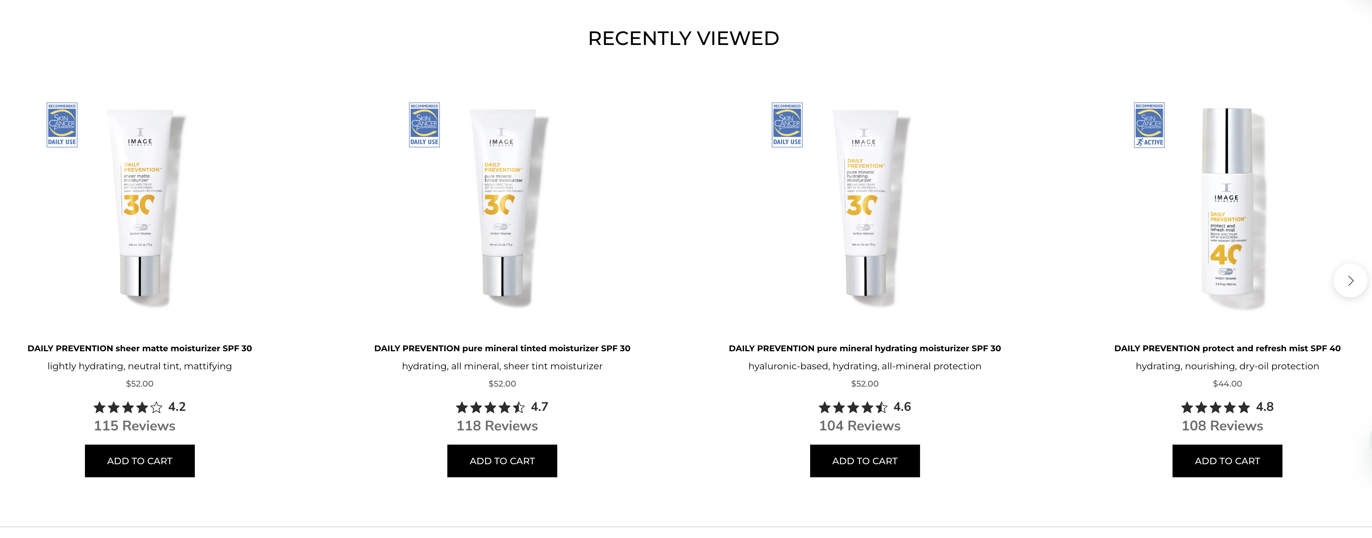

SPECIAL OFFERS

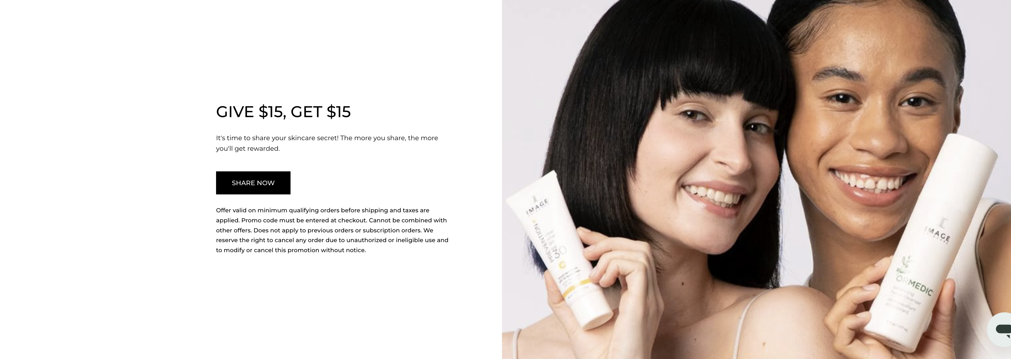

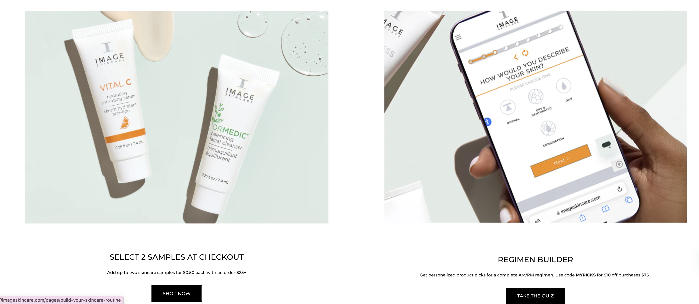

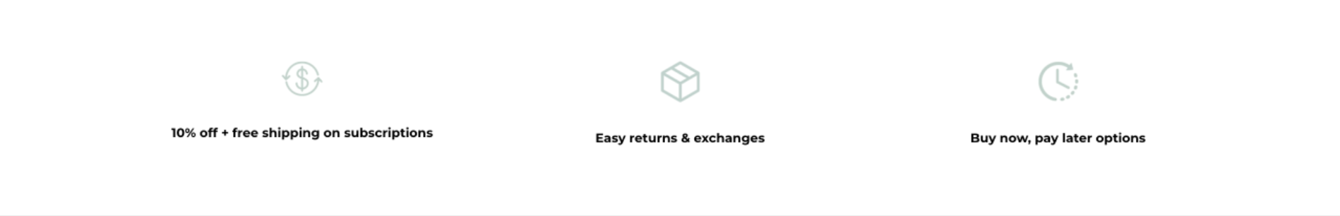

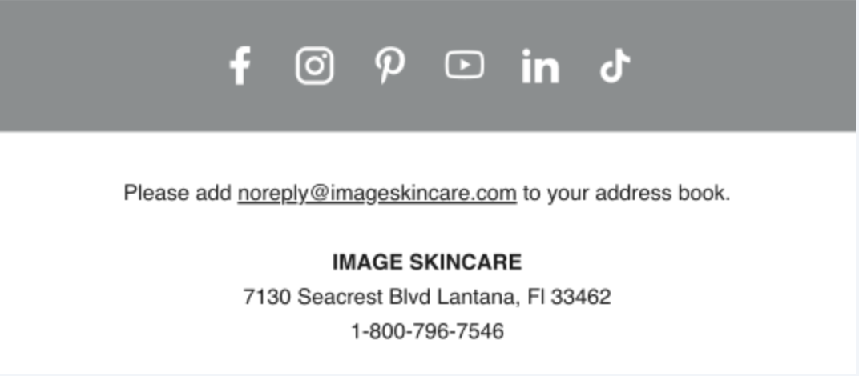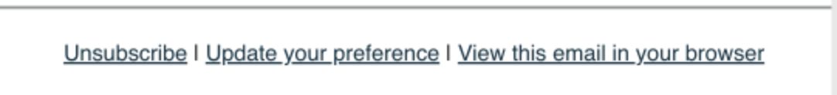

Requirements:

1. Update liquid through this path: Yotpo Reviews > Email Setup > [Customize Your Content Email Template editor](https://share.zight.com/JruZkB5w) > [Reviews comment_notification.liquid](https://share.zight.com/BluP7AP0)
2. Liquid Updates should include the following for the email sent ([document of layout](https://imageskincare.sharepoint.com/:w:/r/Marketing/_layouts/15/doc.aspx?sourcedoc=%7B2fe3a430-ed80-4a5a-861c-d33d6bd2bbee%7D&action=edit)):
3. Image Skincare Logo
4. Include the following [Layout](https://share.zight.com/z8uREgKy) with collection links for (Best Sellers, New Arrivals, Regimen Builder) and product image of product reviewed:
5. Copy underneath image of product reviewed image: "Hi, [Insert Customer First Name], Thank you for submitting a product review for Image Skincare's [Insert Product Name Reviewed]! We appreciate all feedback and hope you enjoy your skincare purchase!
6. Recently Viewed Product Carousel
7. Evergreen offer containers
8. Header Copy: Exclusive Offers
9. Rotating Image w/ Texts (50/50s)
10. Refer A Friend
11. Image to Use: (in comments)
12. Copy:
13. Header: GIVE $15, GET $15
14. Content: It's time to share your skincare secret! The more you share, the more you'll get rewarded.
15. CTA: SHARE NOW (link to <https://imageskincare.com/pages/share?utm_source=header>)
16. Samples
17. Image to use: (in comments)
18. Copy:
19. Header: SELECT 2 SAMPLES AT CHECKOUT
20. Content: Add up to two skincare samples for $0.50 each with an order $25+
21. CTA: SHOP NOW (link to <https://imageskincare.com/collections/best-sellers>)
22. Regimen Builder:
23. Image to use: (in comments)
24. Copy:
25. Header: REGIMEN BUILDER
26. Content: Get personalized product picks for a complete AM/PM regimen
27. CTA: TAKE QUIZ (link to <https://imageskincare.com/pages/skin-quiz>)
28. [Value Props Icon Banner](https://share.zight.com/mXuQdOBl) use the following order of icons and copy already on D2C offers page for labels underneath icons
29. Use the following svgs comments in the same HEX color
30. [Evergreen Email Footer w/ share social icons](https://share.zight.com/mXuQdOXg) already being used in Klaviyo, mimic the same styling
31. [Unsubscribe links](https://share.zight.com/o0uAozd7)